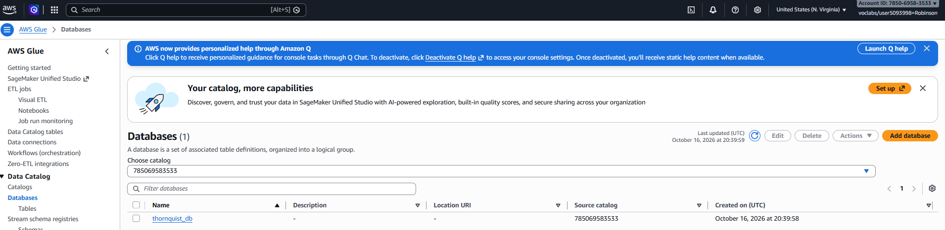
Create the databe using AWSGlue

Create crawler
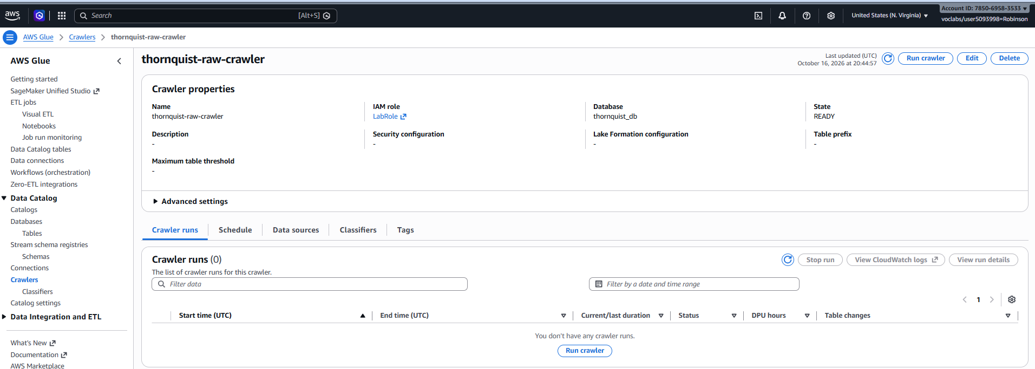

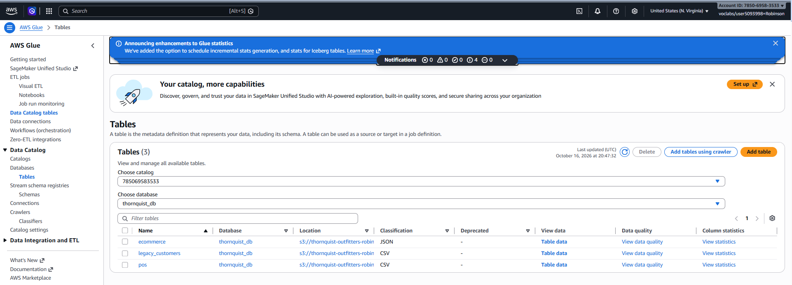
Run and Inspect Tables

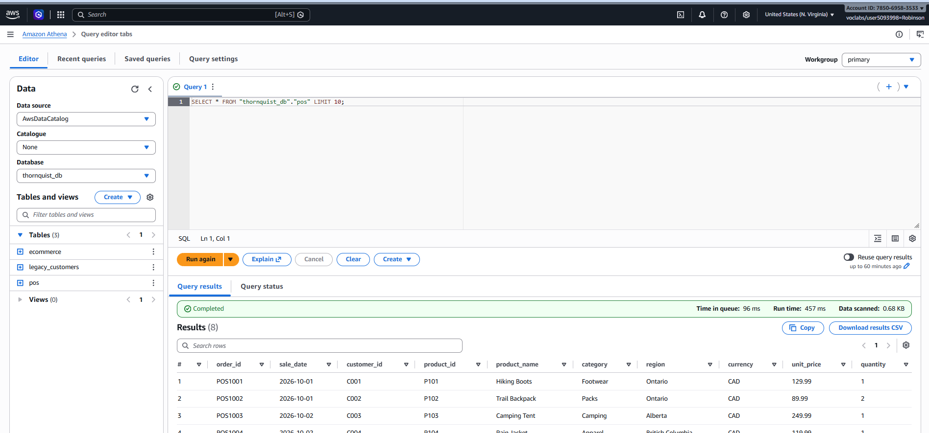
Query the Data on Amazon Athena

Data Quality and Curated Layer
reconciling the structural differences between your three channels (POS CSV, E-commerce JSON, and Legacy Customer flat file).

Schema Conflicts Analysis (Source vs. Source)
Part 1: Schema Conflicts Analysis (Source vs. Source)
Across our three multi-channel input sources, we identified and documented four primary schema conflicts that must be reconciled during the Raw-to-Trusted ETL phase:
1. Inconsistent Date Formats & Malformed Values
- The Conflict:
  - E-commerce JSON (orderDate): Uses US slash formatting (MM/DD/YYYY e.g., "10/01/2026").
  - POS CSV (sale_date): Primarily uses ISO hyphens (YYYY-MM-DD), but contains a corrupted malformed date entry ("2026/99/04" in record POS1006) with an invalid month (99).
  - Legacy Customers (join_date): Uses standard ISO formatting (YYYY-MM-DD).
- The ETL Reconciliation Strategy: Implement a robust PySpark date-parsing routine that normalizes all date fields into a uniform timestamp format (YYYY-MM-DD HH:MM:SS), while routing malformed entries (like 2026/99/04) directly to the Quarantine Zone.
2. Differing Product Taxonomies & Categorizat
  - POS Data (category): Uses terms such as "Footwear", "Packs", "Camping", "Apparel", and "Accessories".
  - E-commerce Data (productGroup): Uses alternative taxonomy buckets such as "Shoes", "Gear", "Outdoor", and "Clothing".
- The ETL Reconciliation Strategy: Build a conformed dimension mapping dictionary in the Glue ETL script to translate and unify category names (e.g., mapping E-commerce "Shoes" and POS "Footwear" into a standardized conformed category: "Footwear & Shoes").
3. Regional and Geographic Representation
- The Conflict:
  - POS Data (region): Spells out full province names (e.g., "Ontario", "Alberta", "British Columbia", "Quebec").
  - E-commerce & Customers (province): Uses standard two-letter Canadian postal abbreviations (e.g., "ON", "AB", "BC", "QC").
- The ETL Reconciliation Strategy: Create a harmonization lookup case-statement to convert full province names into standard two-letter uppercase abbreviations to ensure seamless analytical grouping in Amazon Athena.
4. Naming Conventions & Structural Column Mismatch
- The Conflict: Column headers and casing styles vary completely across ingestion channels:
  - POS uses snake_case (order_id, product_id, product_name, unit_price).
  - E-commerce uses camelCase (orderNumber, sku, product, productGroup, price, qty).
  - Customers uses snake_case with pipe delimiters (customer_id, customer_name, province, segment, join_date).
- The ETL Reconciliation Strategy: Rename and map all incoming fields into a unified schema standard in the Trusted zone (e.g., standardizing transaction identifiers to order_id, product identifiers to sku, unit prices to unit_price, and quantities to quantity).

Part 2: Data Quality Anomaly Findings & Audit
Profiling the raw records revealed specific integrity violations that our automated data quality gates must catch and quarantine before data is promoted to the Trusted and Curated layers:
Anomaly Type | Source File / Record | Specific Finding | Proposed DQ Gate Action
Duplicate Transaction | POS CSV (POS1005) | Exact duplicate row logged twice for C005 purchasing Water Bottle on 2026-10-03. | Uniqueness Check Failure: Route duplicate order_id records to Quarantine.
Malformed Date Value | POS CSV (POS1006) | Field sale_date contains "2026/99/04", an impossible calendar date. | Validity/Range Check Failure: Intercept and quarantine rows with invalid date formats.
Orphaned Foreign Key (Invalid ID) | E-commerce JSON (WEB2003) | Customer ID C999 appears on an order, but does not exist in the customer master table (thornquist_customers.txt). | Referential Integrity Check Failure: Quarantine sales linked to non-existent customers.
Placeholder / Missing Customer | E-commerce JSON (WEB2004) | Customer ID is explicitly recorded as "UNKNOWN". | Completeness Check Failure: Quarantine orders lacking a valid registered customer reference.
Customer Segment Status Unknown | Customer File (C007) | Customer Riley Davis has segment value marked as "UNKNOWN". | Completeness / Null Check: Flag for review or fallback default imputation in the trusted customer dimension.

ETL Ingestion & Schema Harmonization Pipeline
This AWS Glue Studio Visual ETL job ingests heterogeneous source datasets from the Raw layer, resolves schema discrepancies, and outputs standardized, production-ready Parquet files into the Trusted S3 data lake layer.
1. Ingestion Sources & Schema Harmonization
- POS Sales (Raw_POS_Sales): Ingests point-of-sale transactional data. Standardized via Change Schema transform to map field names to uniform snake case naming conventions and appropriate primitive data types.
- E-commerce Orders (Raw_Ecommerce_Orders): Processes semi-structured online order records. Utilizes a Flatten dynamic transform to expand nested JSON array elements into flat tabular records before applying a Change Schema node to match the conformed sales structure.
- Legacy Customers (Raw_Legacy_Customers): Ingests raw customer dimension records. Maps positional headerless CSV attributes (col0–col4) to standardized attributes (customer_id, customer_name, province, segment, join_date) via Change Schema.
2. Consolidated Transformation & Storage Architecture
Source Object | Applied Transforms | Target Storage Path | Target Format
Sales Datasets (POS + E-commerce) | Flatten $→$ Change Schema $→$ Union | s3://thornquist-outfitters-robinson/trusted/conformed_sales/ | Apache Parquet (Snappy)
Customer Dimension (Legacy Customers) | Change Schema (Mapping) | s3://thornquist-outfitters-robinson/trusted/customers/ | Apache Parquet (Snappy)
3. Key Findings & Technical Solutions
- Schema Reconciliation: Resolved schema mismatches between POS and E-commerce channels by projecting all attributes into a unified target schema prior to execution of the Union transform.
- Semi-structured Data Flattening: Successfully resolved nested array structures in E-commerce orders using the Glue Flatten node, ensuring zero data loss during tabular conversion.
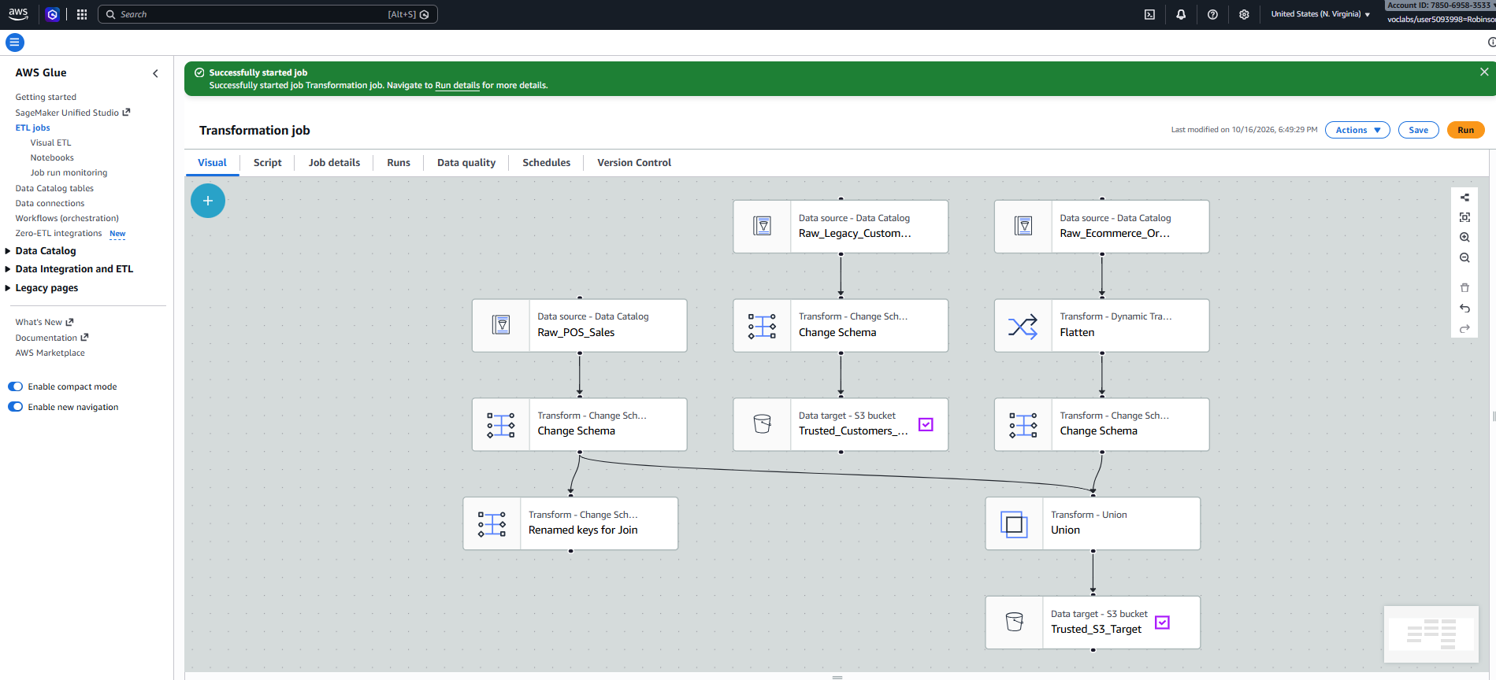
- Decoupled Data Catalog Registration: Disabled interactive catalog update triggers inside the Glue Studio job nodes to prevent IAM session/role permission constraints (AccessDeniedException), opting to register the Trusted layer Parquet tables directly via Amazon Athena DDL.

Adding Curated Layer (Parquet + Partition)
- Wrote conformed sales data into Apache Parquet format with Snappy compression.
- Implemented Data Partitioning by category (category=Accessories, Apparel, Camping, Clothing, Footwear, Gear, Outdoor, Packs) at s3://thornquist-outfitters-robinson/curated/conformed_sales/ to minimize data scan costs and optimize Athena analytical queries.
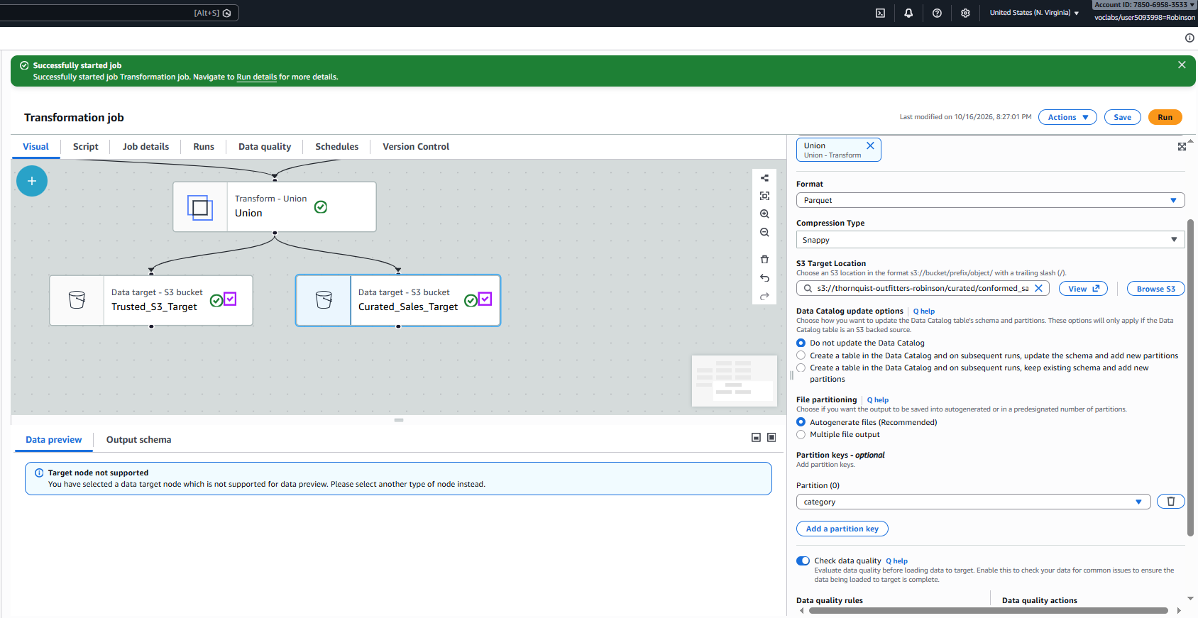

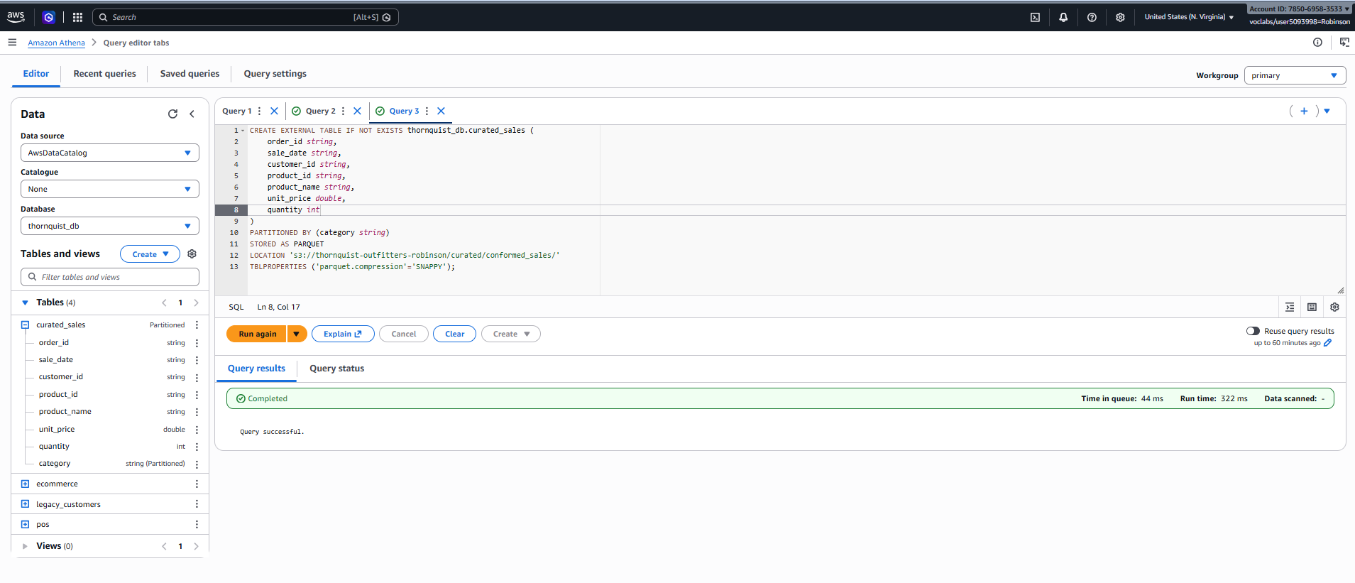
Registry Curated Table in Athena

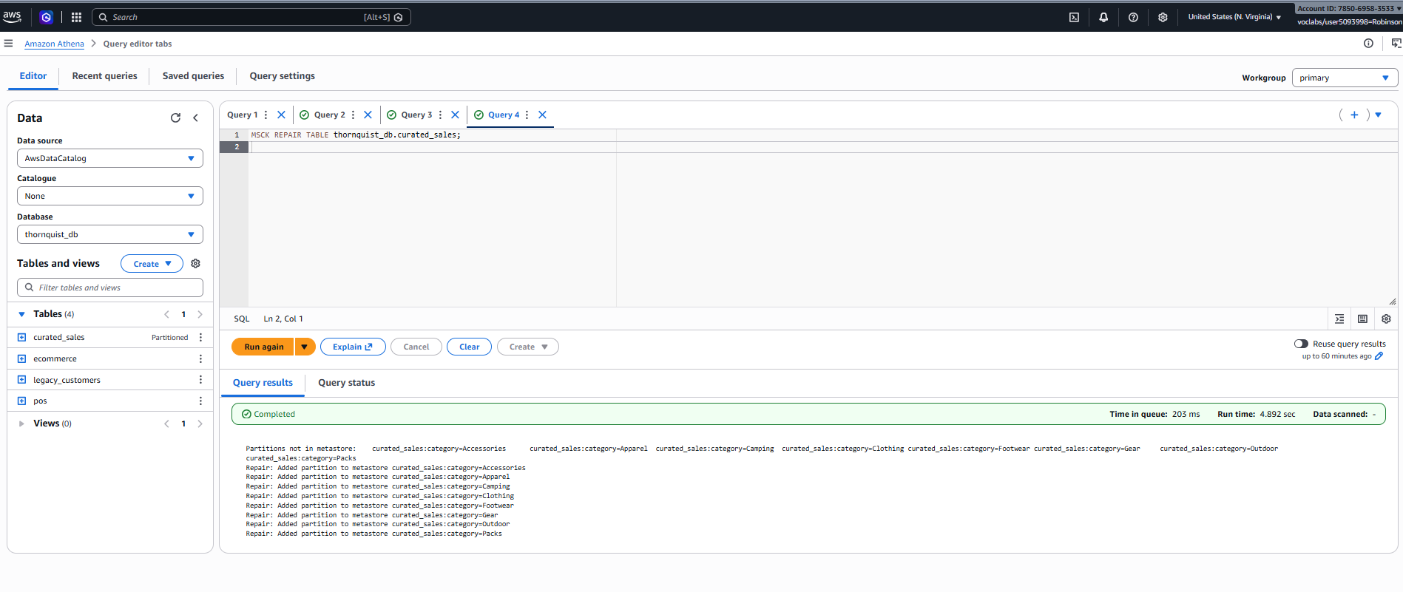
Partition Metadata Registration: Executed MSCK REPAIR TABLE in Athena, successfully discovering and registering all physical S3 partition paths into the Glue Data Catalog.
Query Validation: Successfully executed verification queries (SELECT * FROM thornquist_db.curated_sales LIMIT 10) returning clean, conformed, multi-channel transactional records ready for downstream Business Intelligence (BI) consumption.

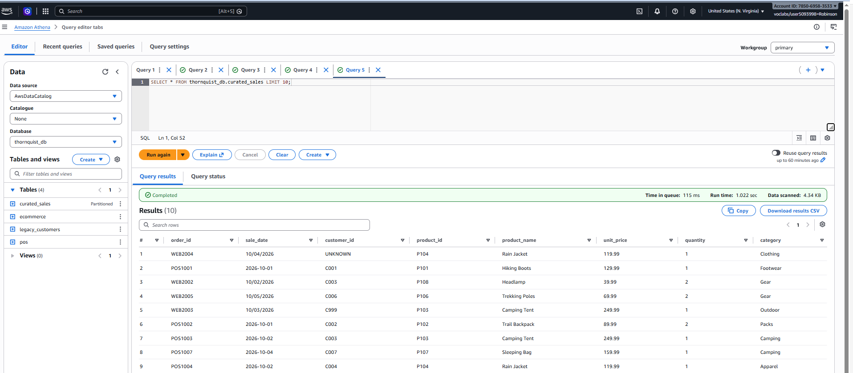

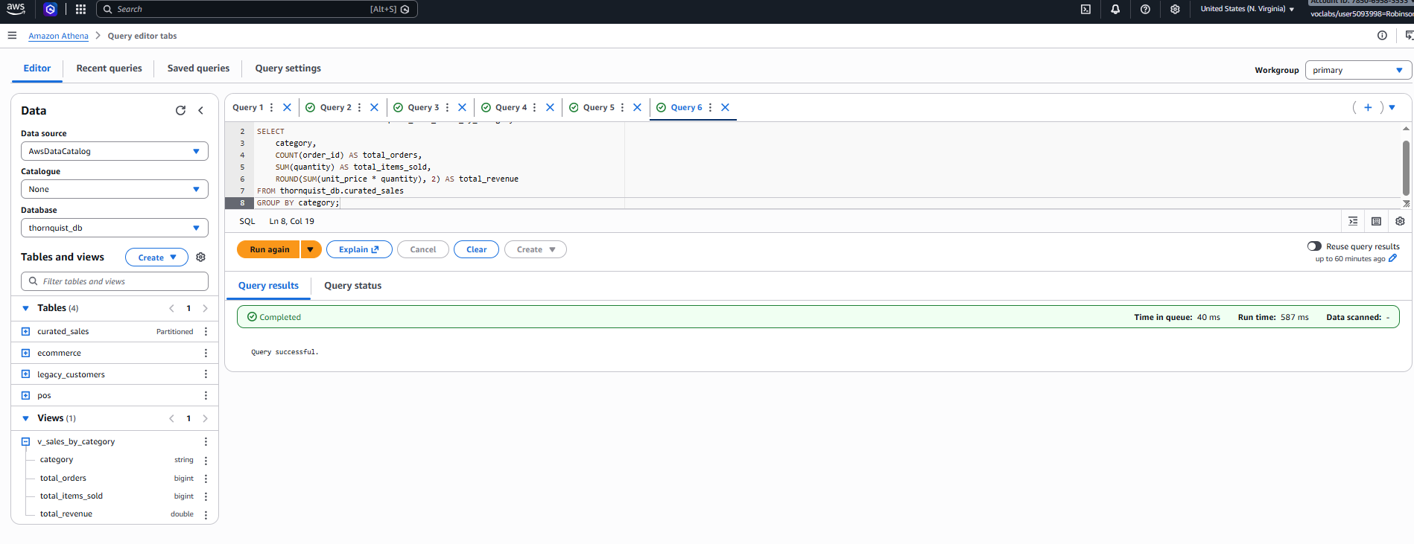
Creation of a View:
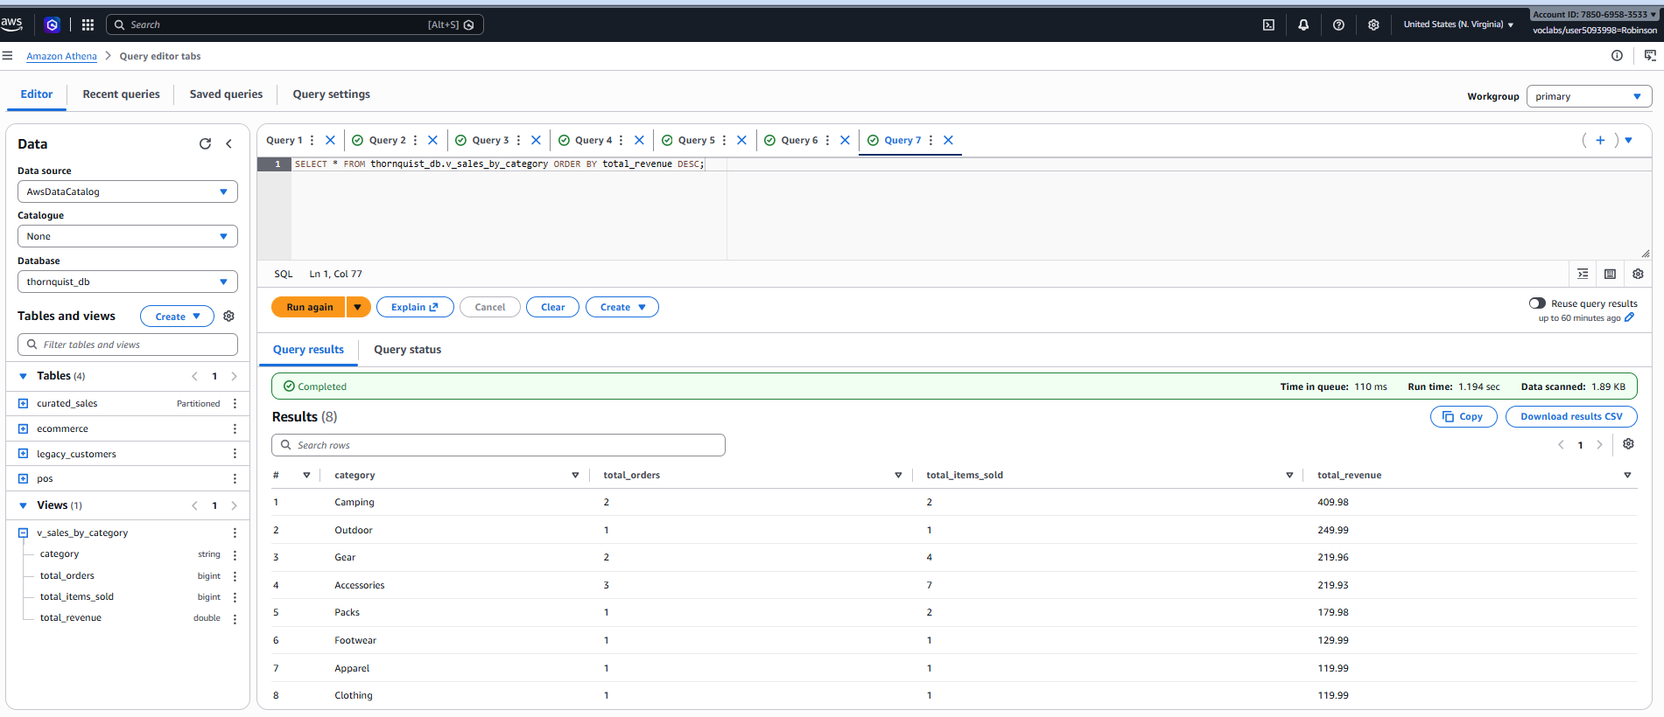
Using the view:

